**Experiment 11**

**Aman Tyagi**

**Aim:** Deploying a service in Kubernetes

1. Starting dashboard

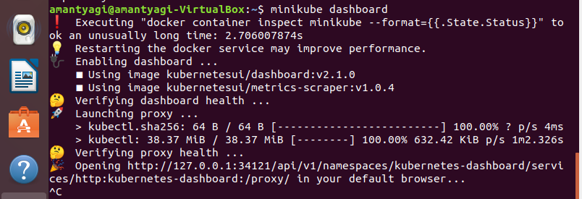

1. Creating a deployment



1. Checking for the events

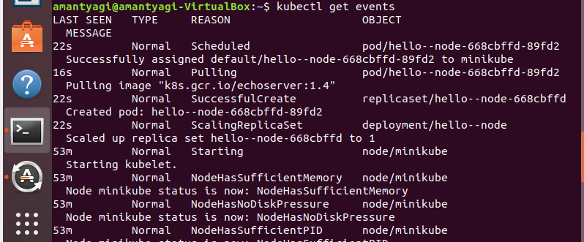  
4. Exposing the service



1. Deploying to the port

